DSABDA Lab Exp No.1

**TITLE: DATA WRANGLING I**

**PROBLEM STATEMENT: -**

Perform the following operations using Python on any open source dataset (e.g., data.csv)

Import all the required Python Libraries.

1. Locate open source data from the web (e.g. https://www.kaggle.com).
2. Provide a clear description of the data and its source (i.e., URL of the web site).
3. Load the Dataset into the pandas data frame.
4. Data Preprocessing: check for missing values in the data using pandas insult (), describe () function to get some initial statistics. Provide variable descriptions. Types of variables, etc. Check the dimensions of the data frame.
5. Data Formatting and Data Normalization: Summarize the types of variables by checking the data types (i.e., character, numeric, integer, factor, and logical) of the variables in the data set. If variables are not in the correct data type, apply proper type conversions.
6. Turn categorical variables into quantitative variables in Python.

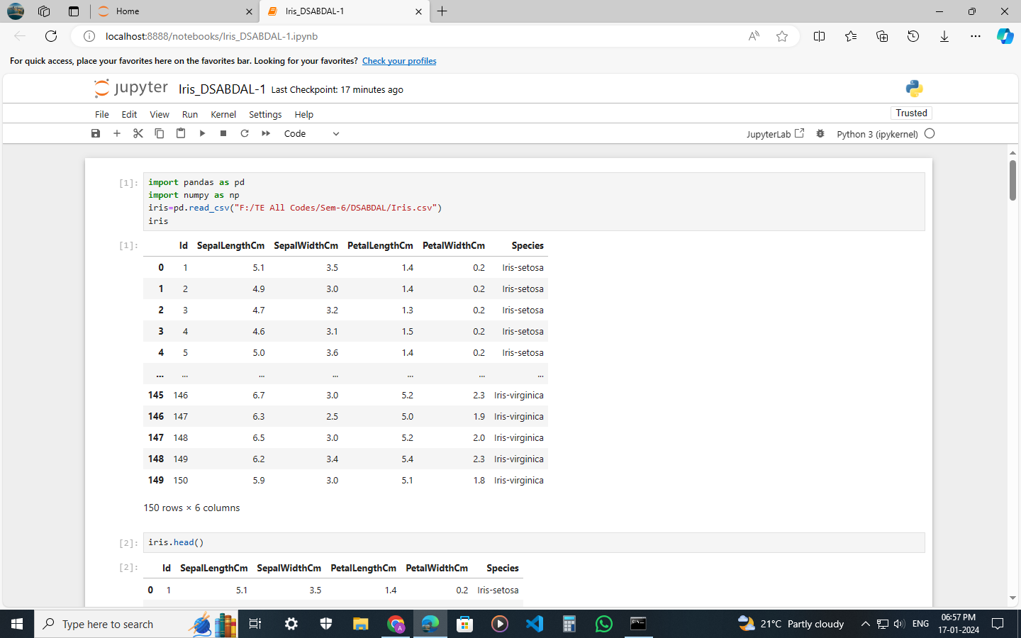OUTPUT:-

